**OUTPUT:**

Shape of dataset: (918, 12)

Info:

<class 'pandas.core.frame.DataFrame'>

RangeIndex: 918 entries, 0 to 917

Data columns (total 12 columns):

# Column Non-Null Count Dtype

--- ------ -------------- -----

0 Age 918 non-null int64

1 Sex 918 non-null object

2 ChestPainType 918 non-null object

3 RestingBP 918 non-null int64

4 Cholesterol 918 non-null int64

5 FastingBS 918 non-null int64

6 RestingECG 918 non-null object

7 MaxHR 918 non-null int64

8 ExerciseAngina 918 non-null object

9 Oldpeak 918 non-null float64

10 ST_Slope 918 non-null object

11 HeartDisease 918 non-null int64

dtypes: float64(1), int64(6), object(5)

memory usage: 86.2+ KB

None

Summary statistics:

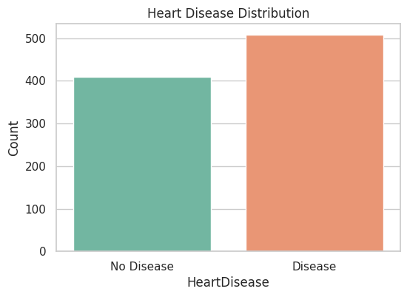

HeartDisease

1 55.337691

0 44.662309

Name: proportion, dtype: float64

RestingBP zero count: 1

Cholesterol zero count: 172

After replacement:

RestingBP zero count: 0

Cholesterol zero count: 0

Training set shape: (734, 11)

Testing set shape: (184, 11)

Logistic Regression Accuracy: 0.8586956521739131

Classification Report:

precision recall f1-score support

0 0.86 0.82 0.84 82

1 0.86 0.89 0.88 102

accuracy 0.86 184

macro avg 0.86 0.85 0.86 184

weighted avg 0.86 0.86 0.86 184

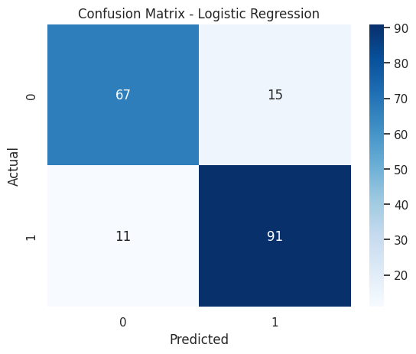

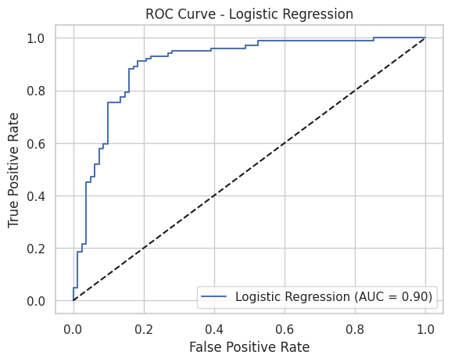

Random Forest Accuracy: 0.875

Classification Report:

precision recall f1-score support

0 0.85 0.88 0.86 82

1 0.90 0.87 0.89 102

accuracy 0.88 184

macro avg 0.87 0.88 0.87 184

weighted avg 0.88 0.88 0.88 184

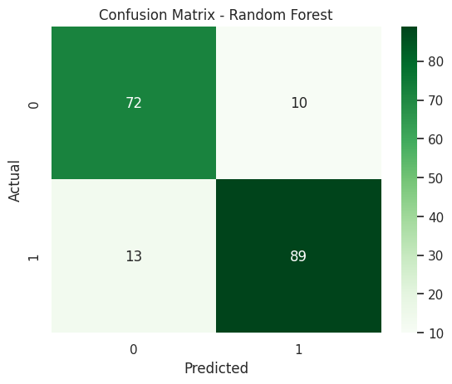

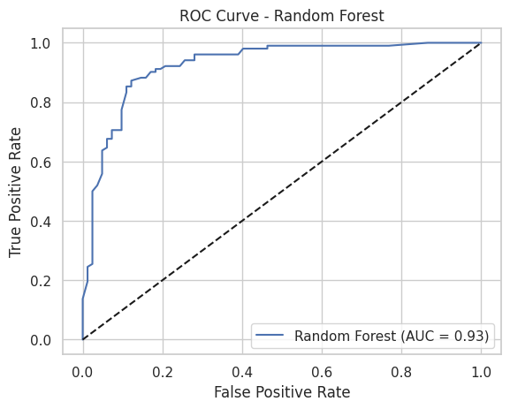

XGBoost Accuracy: 0.8641304347826086

Classification Report:

precision recall f1-score support

0 0.84 0.85 0.85 82

1 0.88 0.87 0.88 102

accuracy 0.86 184

macro avg 0.86 0.86 0.86 184

weighted avg 0.86 0.86 0.86 184

